SVKM’s NMIMS
Mukesh Patel School of Technology Management & Engineering
Computer Engineering Department
Program: BTech Integrated Sem VI

Course: Computer Graphics
2025-26
PART A
(Part A: TO BE REFERRED BY STUDENTS)
Experiment No. 10
A.1 Aim: Write a program to implement Cohen-Sutherland Line Clipping algorithm.
A.2 Prerequisite:
Basic knowledge about Graphics functions

A.3 Outcome:
After successful completion of this experiment students will be able to:
i. Demonstrate different 2-D and 3-D geometric transformations, viewing and clipping techniques.
A.4 Theory:
Graphics Functions:

Rectangle function:
Declaration: rectangle(int left, int top, int right, int bottom);
Rectangle function is used to draw a rectangle. Coordinates of left top and right bottom corner are required to draw the rectangle. left specifies the X-coordinate of top left corner, top specifies the Y-coordinate of top left corner, right specifies the X-coordinate of right bottom corner, bottom specifies the Y-coordinate of right bottom corner. The code given below draws a rectangle.
#include<graphics.h>
#include<conio.h>
int main()
{
int gd = DETECT, gm;
initgraph(&gd, &gm, "C:\\TC\\BGI");
rectangle(100,100,200,200);
getch();
closegraph();
return 0;
}
Line Function:
Declaration: line(x1,y1,x2,y2);
We need to pass just 4 parameters to the line() function. Line Function Draws Line From (x1,y1) to (x2,y2) .
#include<graphics.h>
#include<conio.h>
int main()
{
int gd = DETECT, gm;
initgraph(&gd, &gm, "C:\\TC\\BGI");
line(100,100,200,200);
getch();
closegraph();
return 0;
}

Cohen Sutherland Line Clipping:
Clipping is the process of determining the portion of a primitive lying within a region called as clip region.
Clipping of a line depends on the region outcodes. To perform trivial accept and reject tests, we extend the edges of the clip rectangle to divide the 2-D plane into nine regions. Each region is assigned a 4-bit code determined by where the region lies with respect to the outside half planes of the clip-rectangle edges. Each bit in the outcode is set to either 1 (true) or 0 (false). The region which is inside the clip rectangle has four bits which are all 0, hence the line is accepted. If at both endpoints of a line, there is 1 at the same bit position then the line is trivially rejected. The 4 bits in the code correspond to the following conditions:
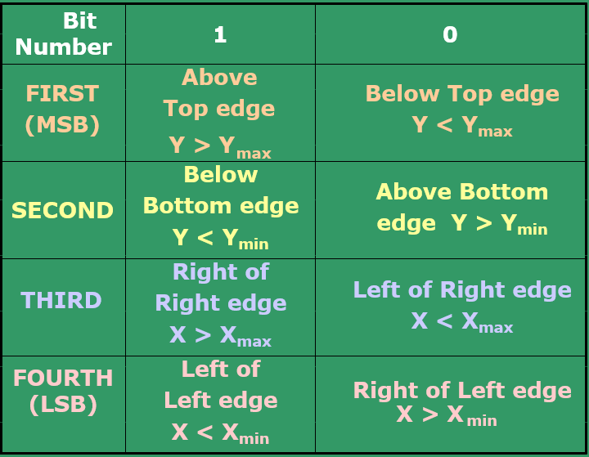
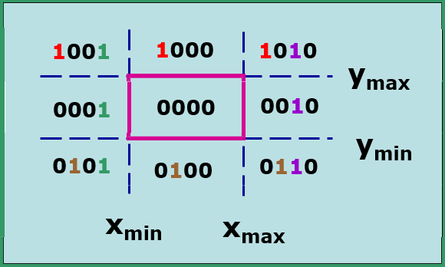

Calculating Line Intersections:
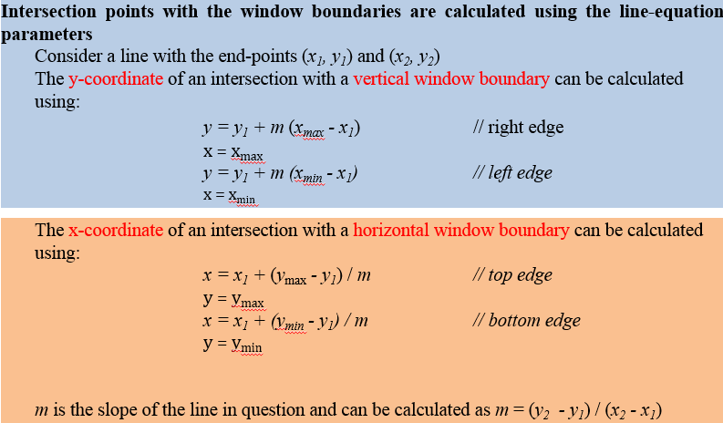
Example:
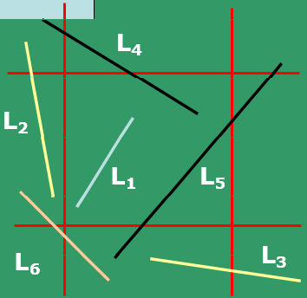
There are 6 lines given below named as L₁, L₂, L₃, L₄, L₅, L_{6 .}

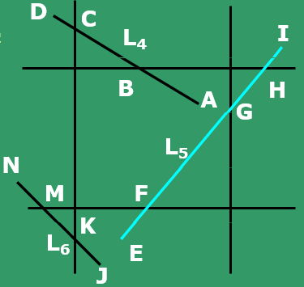
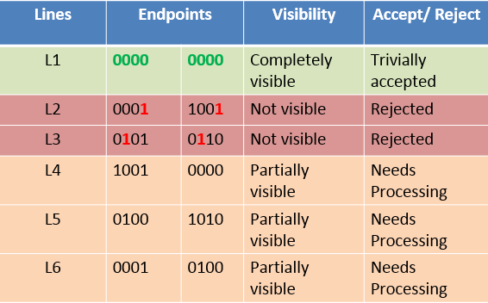
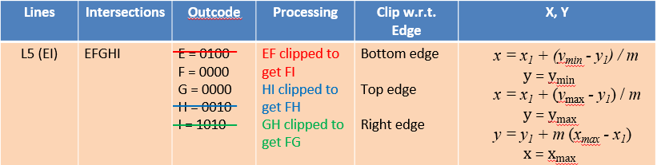

Likewise, solve for L4 and L6.
.PART B
(PART B: TO BE COMPLETED BY STUDENTS)
(Students must submit the soft copy as per following segments within two hours of the practical. The soft copy must be uploaded on the Blackboard or emailed to the concerned lab in charge faculties at the end of the practical in case the there is no Black board access available)
Roll No.C096 | Name:Sourish Sinha
Program: BTI | Division: C2
Batch:C2 | Date of Experiment: 31/03/26
Date of Submission: 31/03/26 | Grade :

B.1 Write the Cohen Sutherland Line Clipping algorithm.
B.2 Write a program to implement Cohen Sutherland Line Clipping algorithm.
Code:
#include<graphics.h>
#include<iostream>
#include<conio.h>
using namespace std;

int computeCode(int x,int y,int xmin,int ymin,int xmax,int ymax)
{
int code=0;
if(x<xmin)
{
code|=1;
}
else if(x>xmax)
{
code|=2;
}
if(y<ymin)
{
code|=4;
}
else if(y>ymax)
{
code|=8;
}
return code;
}

int main()
{
int gd=DETECT,gm;
int x1,y1,x2,y2;
int xmin,ymin,xmax,ymax;
initgraph(&gd,&gm,"");
cout<<"Enter xmin: ";
cin>>xmin;
cout<<"Enter ymin: ";
cin>>ymin;
cout<<"Enter xmax: ";
cin>>xmax;
cout<<"Enter ymax: ";
cin>>ymax;
cout<<"Enter x1: ";
cin>>x1;
cout<<"Enter y1: ";
cin>>y1;
cout<<"Enter x2: ";
cin>>x2;
cout<<"Enter y2: ";
cin>>y2;
rectangle(xmin,ymin,xmax,ymax);
int code1=computeCode(x1,y1,xmin,ymin,xmax,ymax);
int code2=computeCode(x2,y2,xmin,ymin,xmax,ymax);
int accept=0;
while(true)
{
if(code1==0 && code2==0)
{
accept=1;
break;
}
if(code1 & code2)
{
break;
}
int code_out=code1?code1:code2;
int x,y;

if(code_out & 8)
{
y=ymax;
x=x1+(x2-x1)*(ymax-y1)/(y2-y1);
}
else if(code_out & 4)
{
y=ymin;
x=x1+(x2-x1)*(ymin-y1)/(y2-y1);
}
else if(code_out & 2)
{
x=xmax;
y=y1+(y2-y1)*(xmax-x1)/(x2-x1);
}
else
{
x=xmin;
y=y1+(y2-y1)*(xmin-x1)/(x2-x1);
}

if(code_out==code1)
{
x1=x;
y1=y;
code1=computeCode(x1,y1,xmin,ymin,xmax,ymax);
}
else
{
x2=x;
y2=y;
code2=computeCode(x2,y2,xmin,ymin,xmax,ymax);
}
}
if(accept)
{
line(x1,y1,x2,y2);
cout<<"Line Accepted";
}
else
{
cout<<"Line Rejected";
}
outtextxy(150,320,"Sourish Sinha");
getch();
closegraph();
return 0;
}
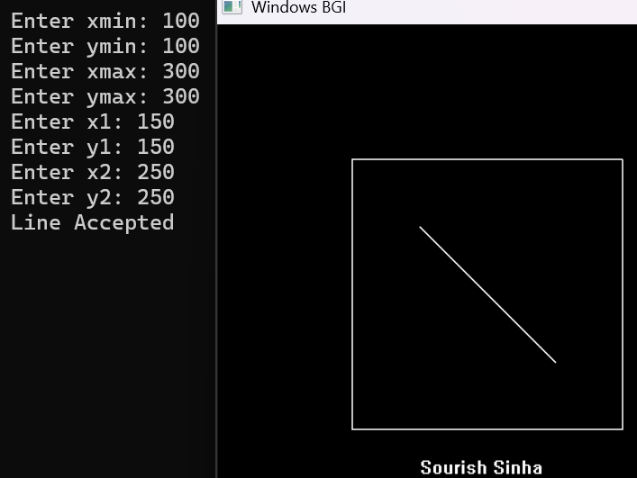
Output:

B.3 Conclusion:
The Cohen–Sutherland Line Clipping algorithm was successfully implemented using graphics functions. The program effectively determines whether a line is completely inside, outside, or partially inside the clipping window using region codes. It accurately clips the line and displays only the visible portion. This experiment helped in understanding fundamental 2D clipping techniques in computer graphics.

